# Bayes Theorem and Bayesian Methods

## Books

* The theory that would not die by Mcgrayne
* Think Bayes by O’Reilly
* Probabilistic Programming and Bayesian Methods for Hackers
* Doing Bayesian Data Analysis
* Bayesian Data Analysis
  + The Bible for it

## Bayes’ Rule

* 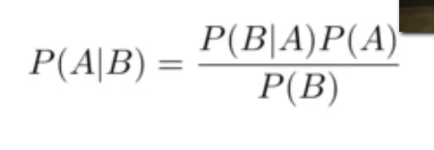

## Discriminative vs Generative Classifiers

* What to model and what not to model?
  + Discriminative: just model p(y|x)
  + Generative: give a full probability model p(x,y)=p(x)p(y|x)=p(y)p(x|y)

### Naïve Bayes

* Assumption: Conditional independence given spam, and also conditional independence given not spam
* Huge simplification in statistical and computational complexity

## Full Probability Modeling

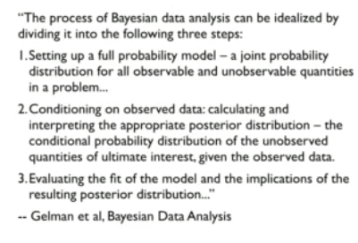

## Conjugate Priors: Beta-Binomial

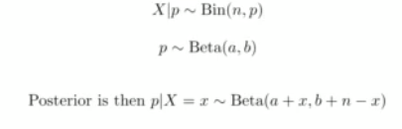

## Conjugate Priors: Normal-Normal

